**What is Machine Learning?**

Machine learning (ML) is a modern software development technique and a type of artificial intelligence (AI) that enables computers to solve problems by using examples of real-world data. It allows computers to automatically learn and improve from experience without being explicitly programmed to do so.

**Summary**

Machine learning is part of the broader field of artificial intelligence. This field is concerned with the capability of machines to perform activities using human-like intelligence. Within machine learning there are several different kinds of tasks or techniques:

* In **supervised learning**, every training sample from the dataset has a corresponding label or output value associated with it. As a result, the algorithm learns to predict labels or output values. We will explore this in-depth in this lesson.
* In **unsupervised learning**, there are no labels for the training data. A machine learning algorithm tries to learn the underlying patterns or distributions that govern the data. We will explore this in-depth in this lesson.
* In **reinforcement learning**, the algorithm figures out which actions to take in a situation to maximize a reward (in the form of a number) on the way to reaching a specific goal. This is a completely different approach than supervised and unsupervised learning. We will dive deep into this in the next lesson.

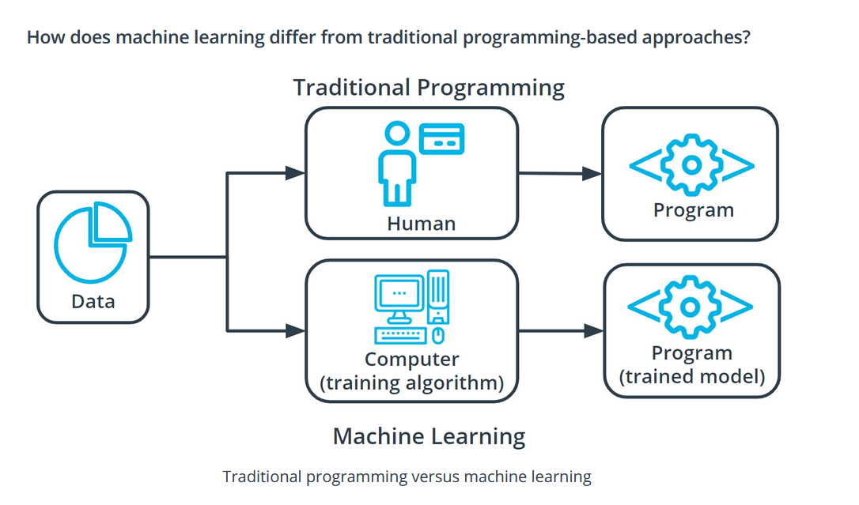

In traditional problem-solving with software, a person analyzes a problem and engineers a solution in code to solve that problem. For many real-world problems, this process can be laborious (or even impossible) because a correct solution would need to consider a vast number of edge cases.

Imagine, for example, the challenging task of writing a program that can detect if a cat is present in an image. Solving this in the traditional way would require careful attention to details like varying lighting conditions, different types of cats, and various poses a cat might be in.

In machine learning, the problem solver abstracts away part of their solution as a flexible component called a *model*, and uses a special program called a *model training algorithm* to adjust that model to real-world data. The result is a trained model which can be used to predict outcomes that are not part of the data set used to train it.

In a way, machine learning automates some of the statistical reasoning and pattern-matching the problem solver would traditionally do.

The overall goal is to use a *model* created by a *model training algorithm* to generate predictions or find patterns in data that can be used to solve a problem.

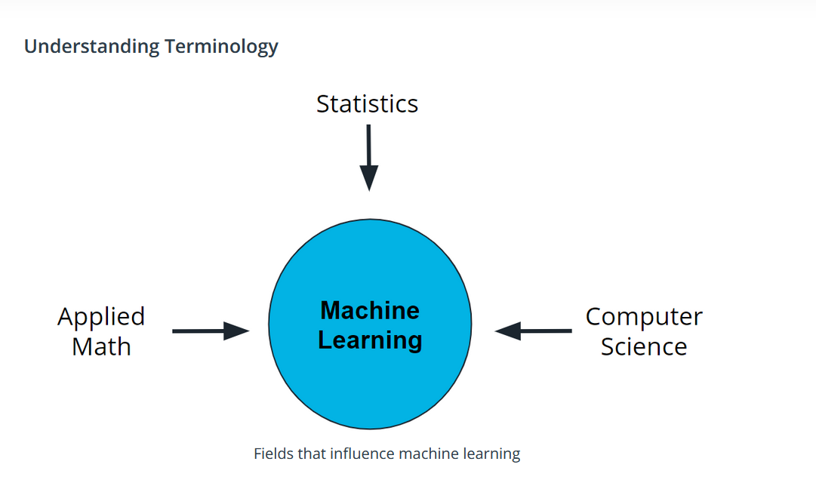

Machine learning is a new field created at the intersection of statistics, applied math, and computer science. Because of the rapid and recent growth of machine learning, each of these fields might use slightly different formal definitions of the same terms.

**Terminology**

**Machine learning**, or *ML*, is a modern software development technique that enables computers to solve problems by using examples of real-world data.

In **supervised learning**, every training sample from the dataset has a corresponding label or output value associated with it. As a result, the algorithm learns to predict labels or output values.

In **reinforcement learning**, the algorithm figures out which actions to take in a situation to maximize a reward (in the form of a number) on the way to reaching a specific goal.

In **unsupervised learning**, there are no labels for the training data. A machine learning algorithm tries to learn the underlying patterns or distributions that govern the data.

**Additional Reading**

* Want to learn more about how software and application come together? Reading through this entry about the [software development process](https://en.wikipedia.org/wiki/Software_development) from Wikipedia can help.